**Analyzing Airbnb Accommodation Dataset**

컴퓨터공학과

2017103948 고다경

1. Dataframe: listing each room_id, host_id with total score in two sorting ways

1. 1)  index = (​**room_id**​, ​**host_id)**
2. 2)  column = ​**total_score**​: **o**​ **verall_satisfaction**​ + ​**reviews * 0.378**
3. 3)  output = ​**1**​. sorted total_score in ascending ​**2**.​ sorted total_score in descending

= sorted_total_score_ascend.csv, sorted_total_score_descend.csv

2. Dataframe: listing average of factors by grouped ​neighborhood

1. 1)  index = (​**neighborhood)**
2. 2)  column = ​**avg of reviews | avg of overall_satisfaction | avg of price | max of reviews | min of reviews | max of price | min of price**
3. 3)  output = ​**1**​. sorted neighborhood in ascending

= sorted_neighborhood_factors.csv

3. Dataframe: listing average of factors by grouped ​ranged prices

index = ranged prices  
output = sort_ranged_price.csv

4. Graph: draw each graph by the following lists

1) lineplot xaxis=rangedprice|yaxis=accommodateaverage

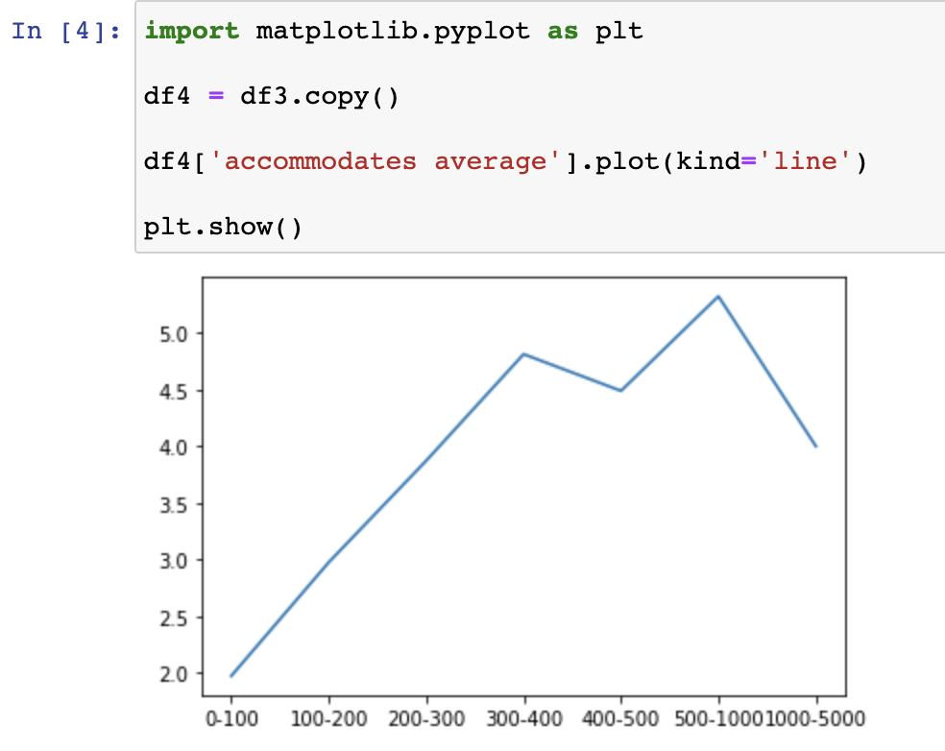

2)  line plot x axis = ranged price | y axis = bedrooms average

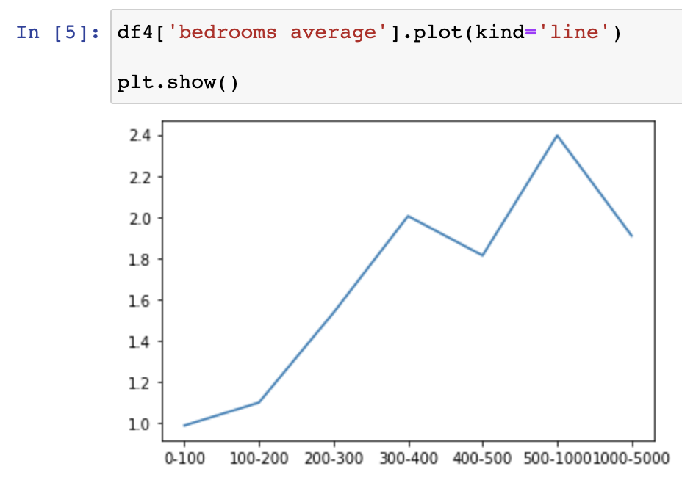

3)  line ​**subplot** x axis = neighborhood

| y axis = reviews average  
| y axis = overall satisfaction average   
| y axis = average price average

